Tips & Tricks using Technology for Partially Sighted Patients

My set up:
Keyboard – Large Print High Contrast Keyboard purchased from eBay for around £25
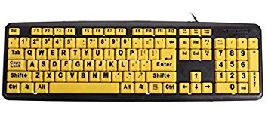
Monitor - Samsung C32F391 32-Inch Curved LED Monitor around £250
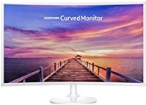
Desktop PC with Windows 10 from around £300 and up
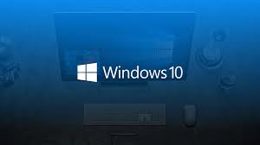
Features in Windows 10 that I use;
HIGH CONTAST
This inverts the colour of the background and the text. I find this much more comforting on the eyes as the white background glares.
Normal;
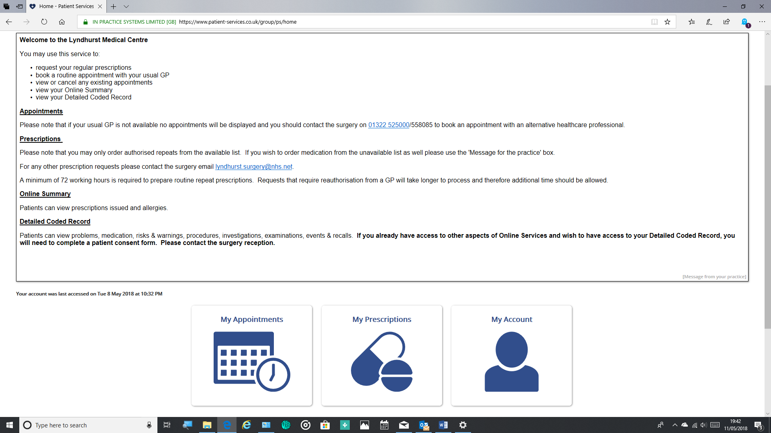
High Contrast;
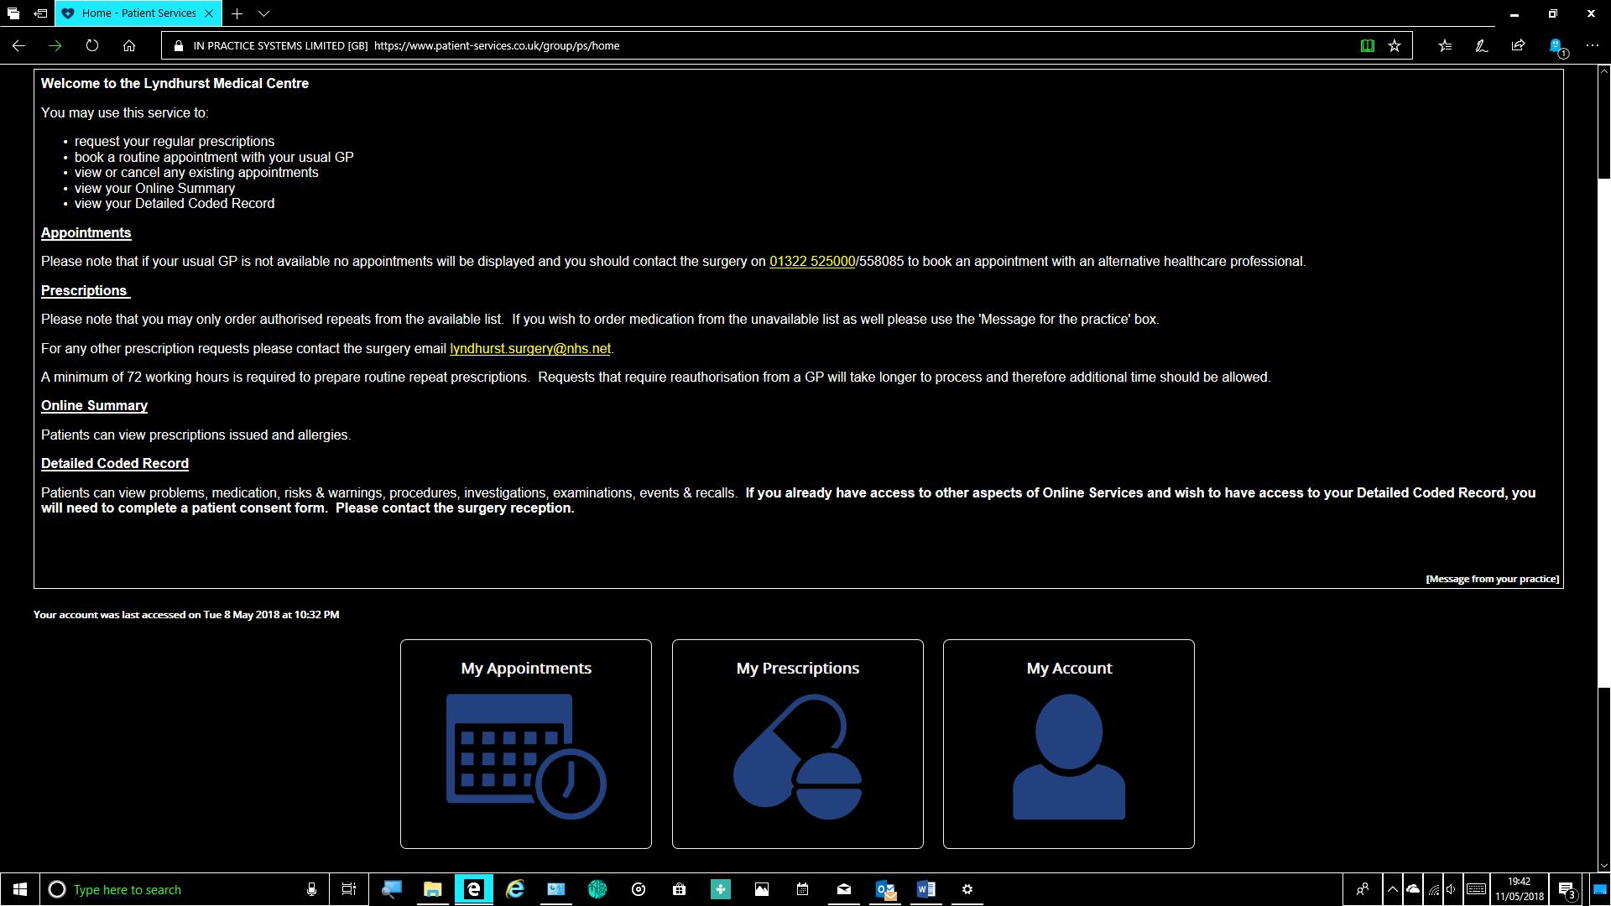

HIGH CONTRAST
To turn on High Contrast I use a keyboard shortcut
Left Alt + left Shift + Print Screen
This will turn High Contrast ON or OFF by pressing the 3 keys at once.
There a several different themes that you can choose. To get to these you need to go to;
Settings > Ease of Access > High Contrast
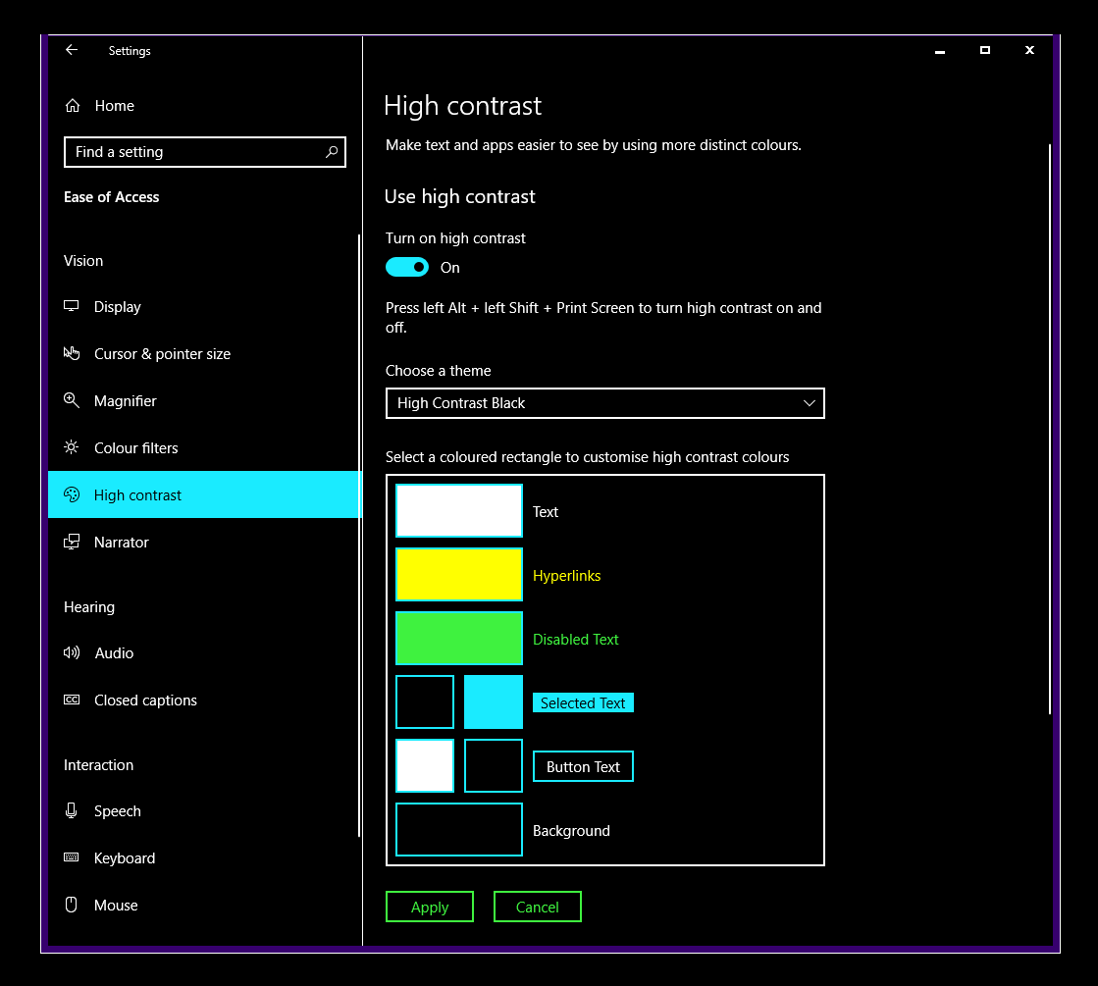
The web browser I use is Microsoft Edge as High Contrast works perfectly in it.

Cursor and Pointer Size
I also adjust the settings of these.
Settings > Ease of Access > Cursor and Pointer Size
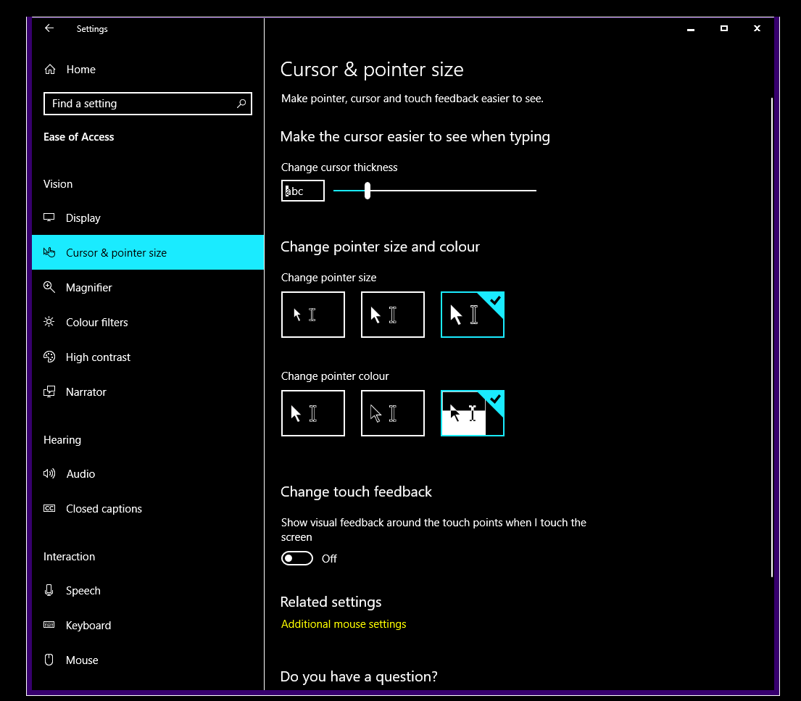

MAGNIFIER
I use MAGNIFIER in LENS MODE. This is basically a magnifier lens which moves with the mouse. There are shortcuts to turn it on/off;
Windows logo key‌ + Plus (+) on the keyboard to turn Magnifier on
Windows logo key + Esc to turn it off.
Again, there are different settings;
Settings > Ease of Access > Magnifier
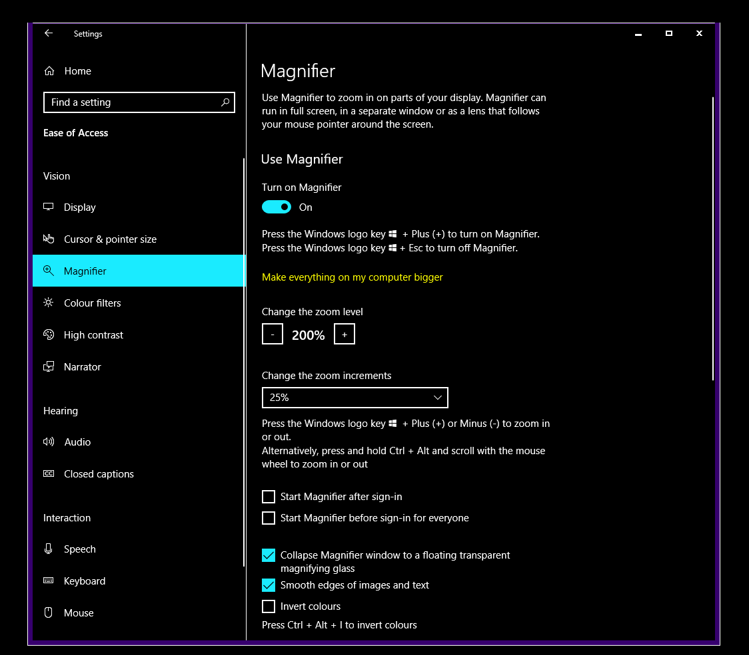
READ ALOUD
Another feature I use is READ ALOUD. Go to the web page you want read. Then just Right Click Mouse and select Read Aloud. You can adjust speed of narrator etc. Settings via; Settings > Ease of Access > Narrator
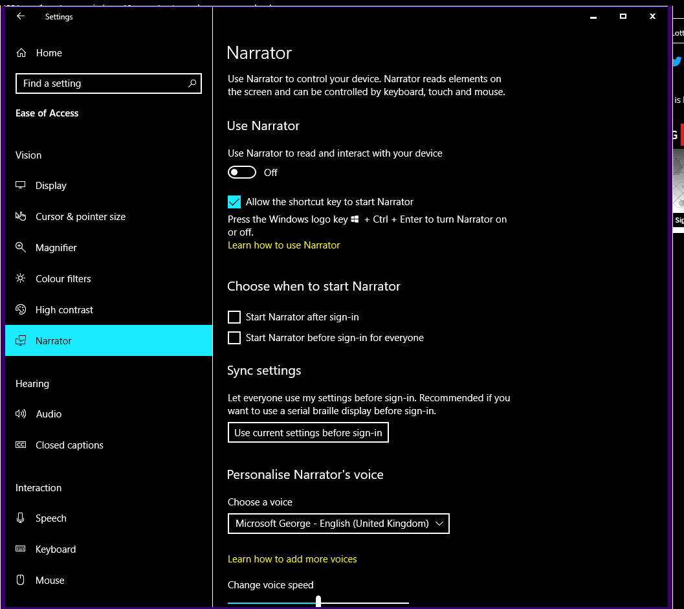

SETTINGS FOR MY iPhone
I also use several features in iOS operating system on my iPhone. I have always had an iPhone so don’t know about Android phones but I’m sure there will be settings foe ease of access somewhere.
I increase Text Size. This is done by;
Settings > Display & Brightness > Text Size

I Zoom Display; The controls are larger
Settings > Display & Brightness > View

Invert Screen
To quickly turn invert screen on and off I have set up a shortcut. By pressing the Home Button THREE TIMES quickly it turns this feature ON/OFF. To set this up;
Settings > General > Accessibility > Accessibility Shortcut > Smart Invert Colours
Invert colours works better in some apps than others. Unfortunately, in some it inverts the pictures too.
Magnifier
I have set up that when I DOUBLE TAP the screen with THREE FINGERS the magnifier is turned ON/OFF.
Settings > General > Accessibility > ZOOM (Turn ON)
There are settings Zoom Region. I use Full Screen Zoom setting.
There’s also Speech but I don’t use this;
Settings > General > Accessibility >Speech

